**Assignment: Inferential and Hypothesis Testing**

Statistics Assignment

**The pharmaceutical company Sun Pharma is manufacturing a new batch of painkiller drugs, which are due for testing. Around 80,000 new products are created and need to be tested for their time of effect (which is measured as the time taken for the drug to completely cure the pain), as well as the quality assurance (which tells you whether the drug was able to do a satisfactory job or not).**

Question-1:

The quality assurance checks on the previous batches of drugs found that — it is 4 times more likely that a drug is able to produce a satisfactory result than not. Given a small sample of 10 drugs, you are required to find the theoretical probability that at most, 3 drugs are not able to do a satisfactory job.

a.) Propose the type of probability distribution that would accurately portray the above scenario, and list out the three conditions that this distribution follows.

b.) Calculate the required probability.

Answer:

The probability that drug is able to produce satisfactory result = 4 * (Probability that drug is not able to produce a satisfactory result)

Thus,

P (drug is able to produce satisfactory result) = 4/5 = 0.8

P (drug is not able to produce satisfactory result) = 1/5 = 0.2

The type of probability distribution that would accurately portray the above scenario is Binomial Distribution.

As per the question, we need to calculate the probabilities for X<=3, i.e. X=0, X=1, X=2, and X=3.

Thus,

Probability that the drug was able to do a satisfactory job=

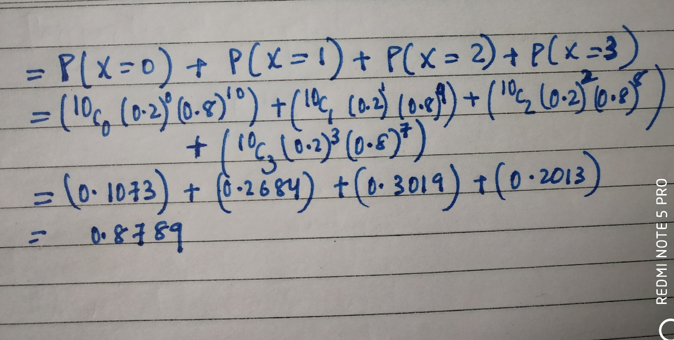

Question-2:

For the effectiveness test, a sample of 100 drugs was taken. The mean time of effect was 207 seconds, with the standard deviation coming to 65 seconds. Using this information, you are required to estimate the range in which the population mean might lie — with a 95% confidence level.

a.) Discuss the main methodology using which you will approach this problem. State all the properties of the required method. Limit your answer to 150 words.

b.) Find the required range.

Answer:

The above problem could be solved using Central Limit Theorem provided a high number of samples has been taken (n>30).

According to the question,

The sample of size, n=100

The sample mean, $\overline{X}$ =207

Standard deviation, S=65

The confidence level is 95%

Thus, corresponding Z value is ± 1.96

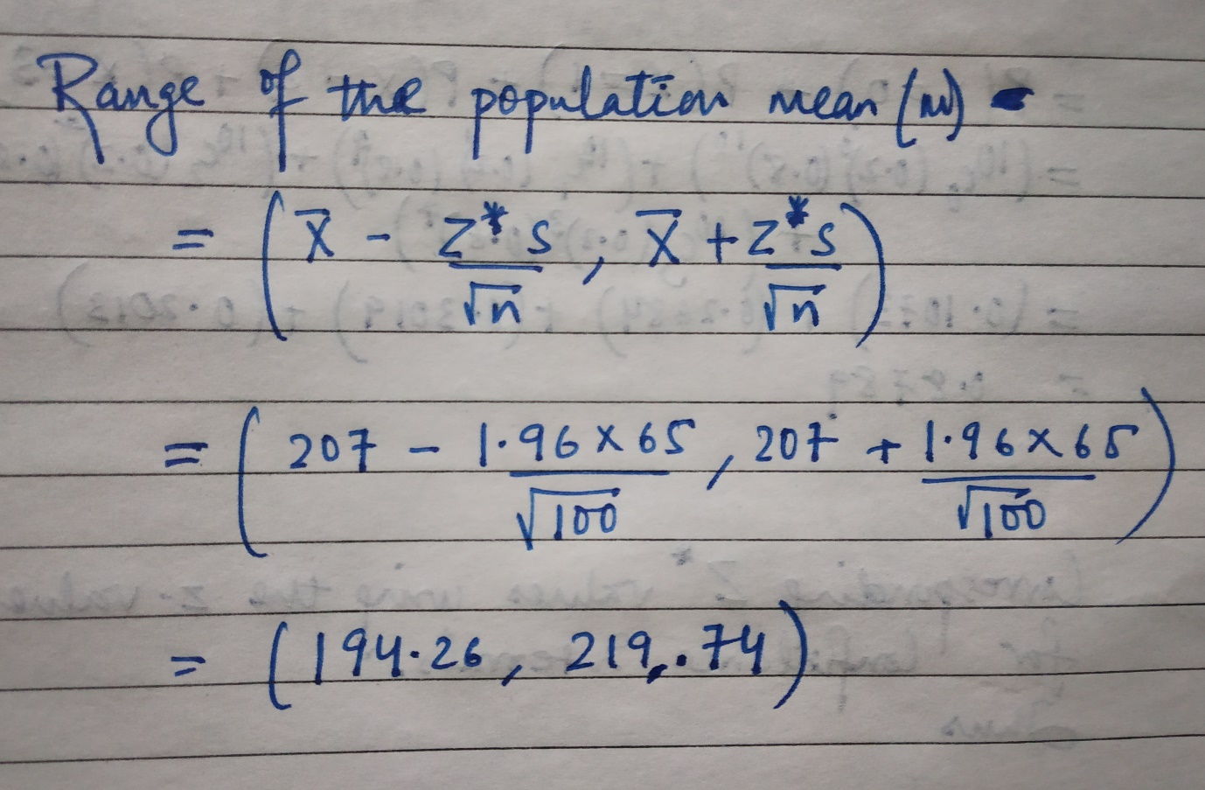

**Thus, the range in which the population mean time will lie with 95% confidence level is from 194.26 seconds to 219.74 seconds.**

Question-3:

a) The painkiller drug needs to have a time of effect of at most 200 seconds to be considered as having done a satisfactory job. Given the same sample data (size, mean, and standard deviation) of the previous question, test the claim that the newer batch produces a satisfactory result and passes the quality assurance test. Utilize 2 hypothesis testing methods to make your decision. Take the significance level at 5 %. Clearly specify the hypotheses, the calculated test statistics, and the final decision that should be made for each method.

b) You know that two types of errors can occur during hypothesis testing — namely Type-I and Type-II errors — whose probabilities are denoted by α and β respectively. For the current hypothesis test conditions (sample size, mean, and standard deviation), the value of α and β come out to 0.05 and 0.45 respectively.

Now, a different sampling procedure is proposed so that when the same hypothesis test is conducted, the values of α and β are controlled at 0.15 each. Explain under what conditions would either method be more preferred than the other.

Answer:

1. The Null hypothesis will be:

The painkiller drug has a time of effect of at most 200 seconds

Or H0: μ ≤ 200

The Alternate hypothesis will be:

The painkiller drug has a time of effect of more than 200 seconds

Or H1: μ > 200

Here,

The population mean, μ =200, sample mean, $μ_{\hat{x}}$ = 207,

sample of size, n=100, sample mean, X=207,

standard deviation, S=65, significance level = 5%

i)Using the critical value method,

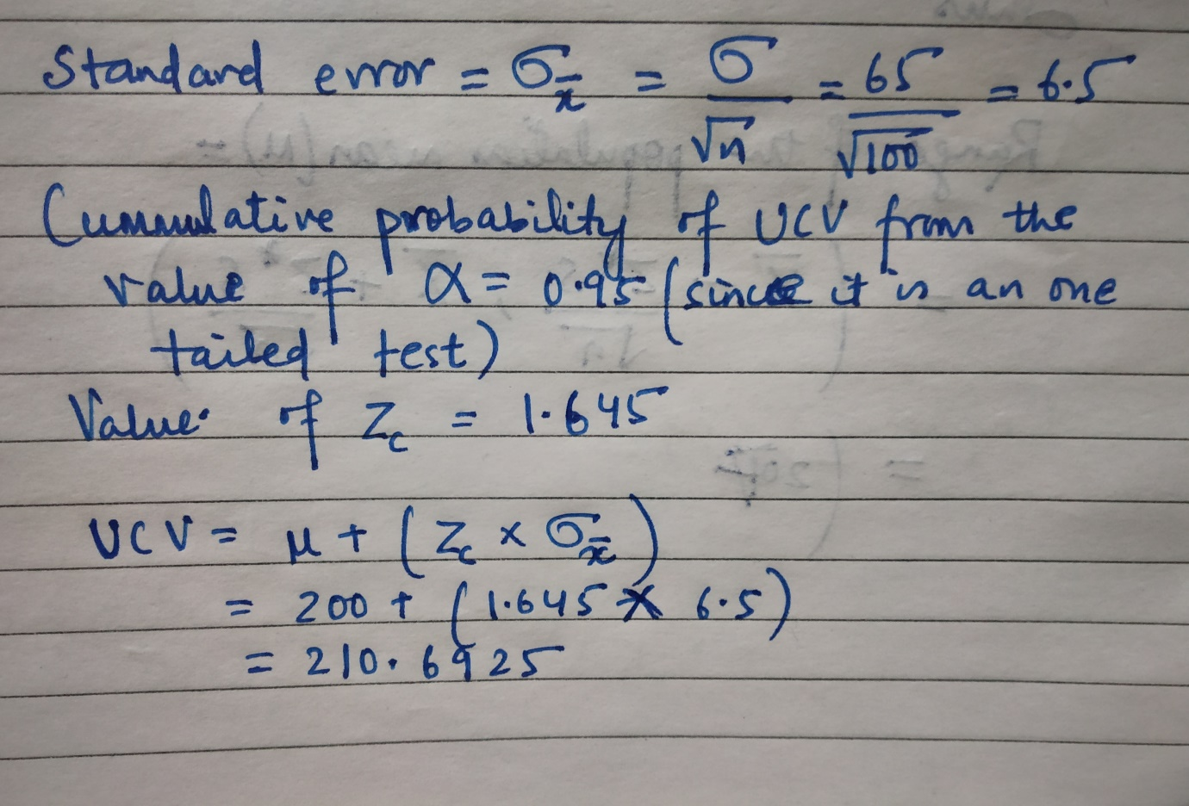

Since our sample mean $μ_{\hat{x}}$ = 207 which is less than our Upper Critical

Value of 210.6925. Thus, **we fail to reject the Null Hypothesis**.

ii) Using the p-value method,

Z-score = ( $\overline{X}$ − μ)/(σ/√n) = (207-200)/(65/10) = (7)/(6.5) = 1.0769 ≈ 1.077

The sample mean is on the right side of the distribution mean (the z-score is positive)

Cumulative probability of sample point (using Z-table) = 0.8577 (it is a one tail test)

Therefore, cumulative probability = 0.8577

For one-tailed test,

p = 1 - 0.8577 = 0.1423

As p-value (0.1423) is greater than the value of α (0.05).

Thus, we fail to reject the Null Hypothesis.

**b)** Type I error occurs when the null hypothesis is true but we reject it,

i.e. reject H0 when it is true

Type II error occurs when the null hypothesis is false but we fail to reject it,

i.e. fail to reject H0 when it is false

For, α = 0.05 and β = 0.45

This means that in 5% of cases, the painkiller drug has a time of effect of at most 200 seconds but we rejected that. In 45% of cases, the painkiller drug has a time of effect of at more than 200 seconds but we accepted that. This means roughly 45% of our drugs did not produce a satisfactory result and 5% of drugs that could produce satisfactory results were rejected.

For, α = 0.15 and β = 0.15

This means that in 15% of cases, the painkiller drug has a time of effect of at most 200 seconds but we rejected that. In 15% of cases, the painkiller drug has a time of effect of at more than 200 seconds but we accepted that. This means roughly 15% of our drugs did not produce a satisfactory result and 15% of drugs that could produce satisfactory results were rejected.

The result of the painkiller drug will be unsatisfactory in roughly 15% cases. 15% of drugs are being rejected. **If the company wants to focus on the effectiveness of painkiller drug and is comfortable with higher operational cost and wastage, this sampling method is better.**

Question-4:

Now, once the batch has passed all the quality tests and is ready to be launched in the market, the marketing team needs to plan an effective online ad campaign for its existing subscribers. Two taglines were proposed for the campaign, and the team is currently divided on which option to use. Explain why and how A/B testing can be used to decide which option is more effective. Give a stepwise procedure for the test that needs to be conducted.

Answer:

A/B testing is a direct industry application of the two-sample proportion test sample. It helps us to statistically figure out the better version of the two taglines. We can implement A/B testing by the following steps:

**Step 1: Identify the test variable**

In our case, there are two different taglines on the online ad campaign platform. Thus, our test variable is the tagline.

**Step 2: Create a 'control' and a 'challenger'**

One of the taglines will be considered control while the other will be considered challenger.

**Step 3: Form a hypothesis**

Let's say our hypothesis is that the control tagline is equally good or better than challenger tagline.

**Step 4: Split your sample groups equally and randomly**

Half of the random visitors should see the control tagline and remaining visitors should see the challenger tagline.

**Step 5: Test both variations simultaneously**

Test both the variations and collect feedback from visitors on both the platform. If there is an action associated with the ad campaign, measure the action response on the two variations of the ad campaign.

**Step 6: Give the A/B test enough time to produce useful data**

A significant number of visitors must visit both the variations of the ad campaign before we can conclude any result from the A/B test.

**Step 7: Take action based on the result of A/B testing**

We can now decide on which tagline is better than the other. We may use the result of A/B testing and then make changes to the ad campaign accordingly.